EX. NO: 02

DATE:13.10.2020

AIM:

To write a python program to count the number x in a given list of numbers*.*

**PROGRAM:**

def count(lst, x):

count = 0

for ele in lst:

if ele == x:

count=count+1

print(count)

lst =[]

n = int(input())

for i in range (0,n):

ele = int(input())

lst.append (ele)

x = int (input ())

count(lst,x)

**LINK:**

http://103.53.53.18/mod/vpl/forms/edit.php?id=230&userid#vpl_file0

**OUTPUT:**

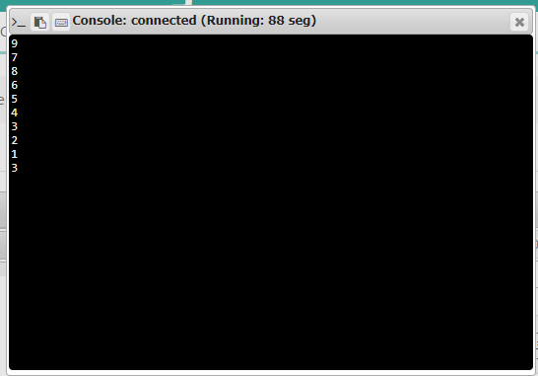

**RESULT:**

The output of the program is successfully obtained